**FACE DETECTION APPLICATION USING AWS - REPORT**

**NAME:** Jeevan Prakash R

**COLLEGE:** VIT Chennai

**COLLEGE REGISTRATION NUMBER:** 16MIS1024

**E-MAIL:** [jeevanprakash1998@gmail.com](mailto:jeevanprakash1998@gmail.com)

**SCREENSHOTS:**

**Dashboards:**

1. AWS Login screen with username

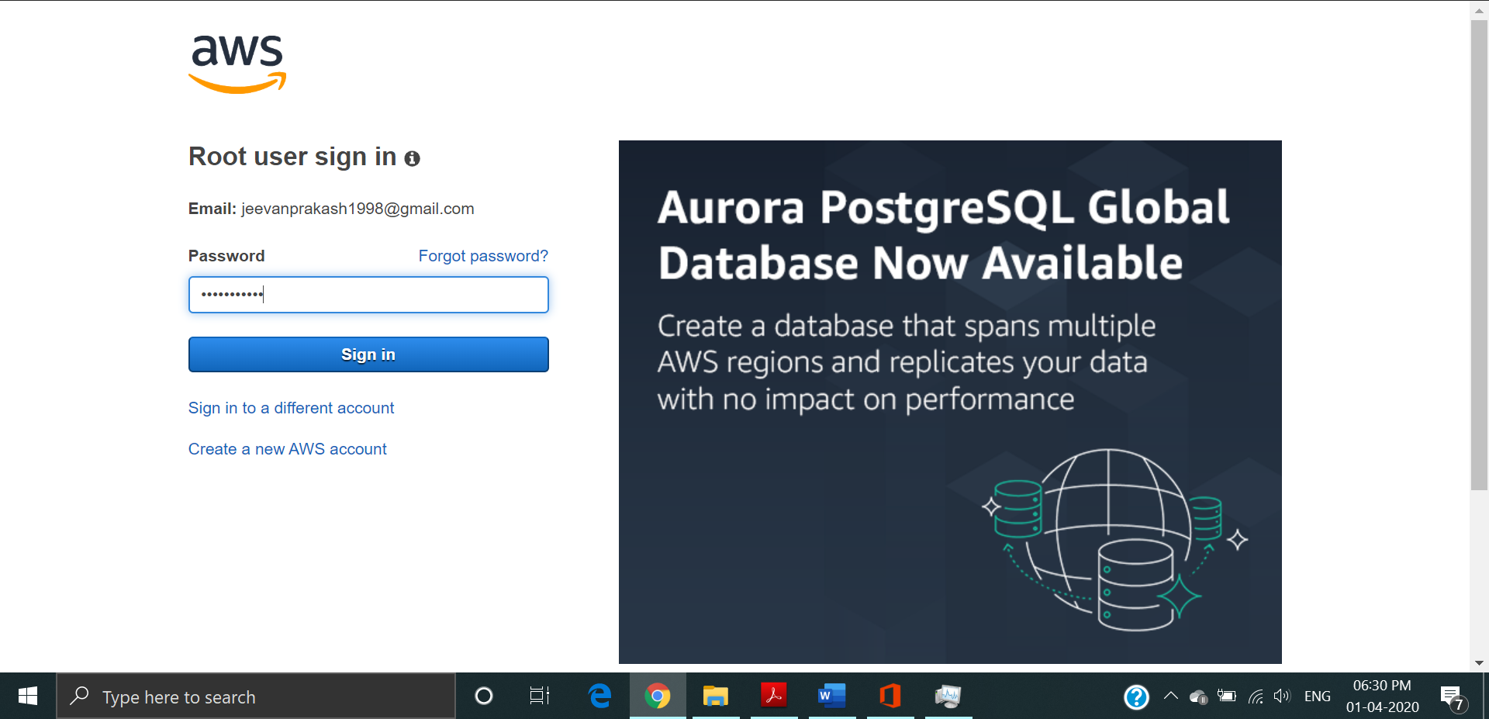

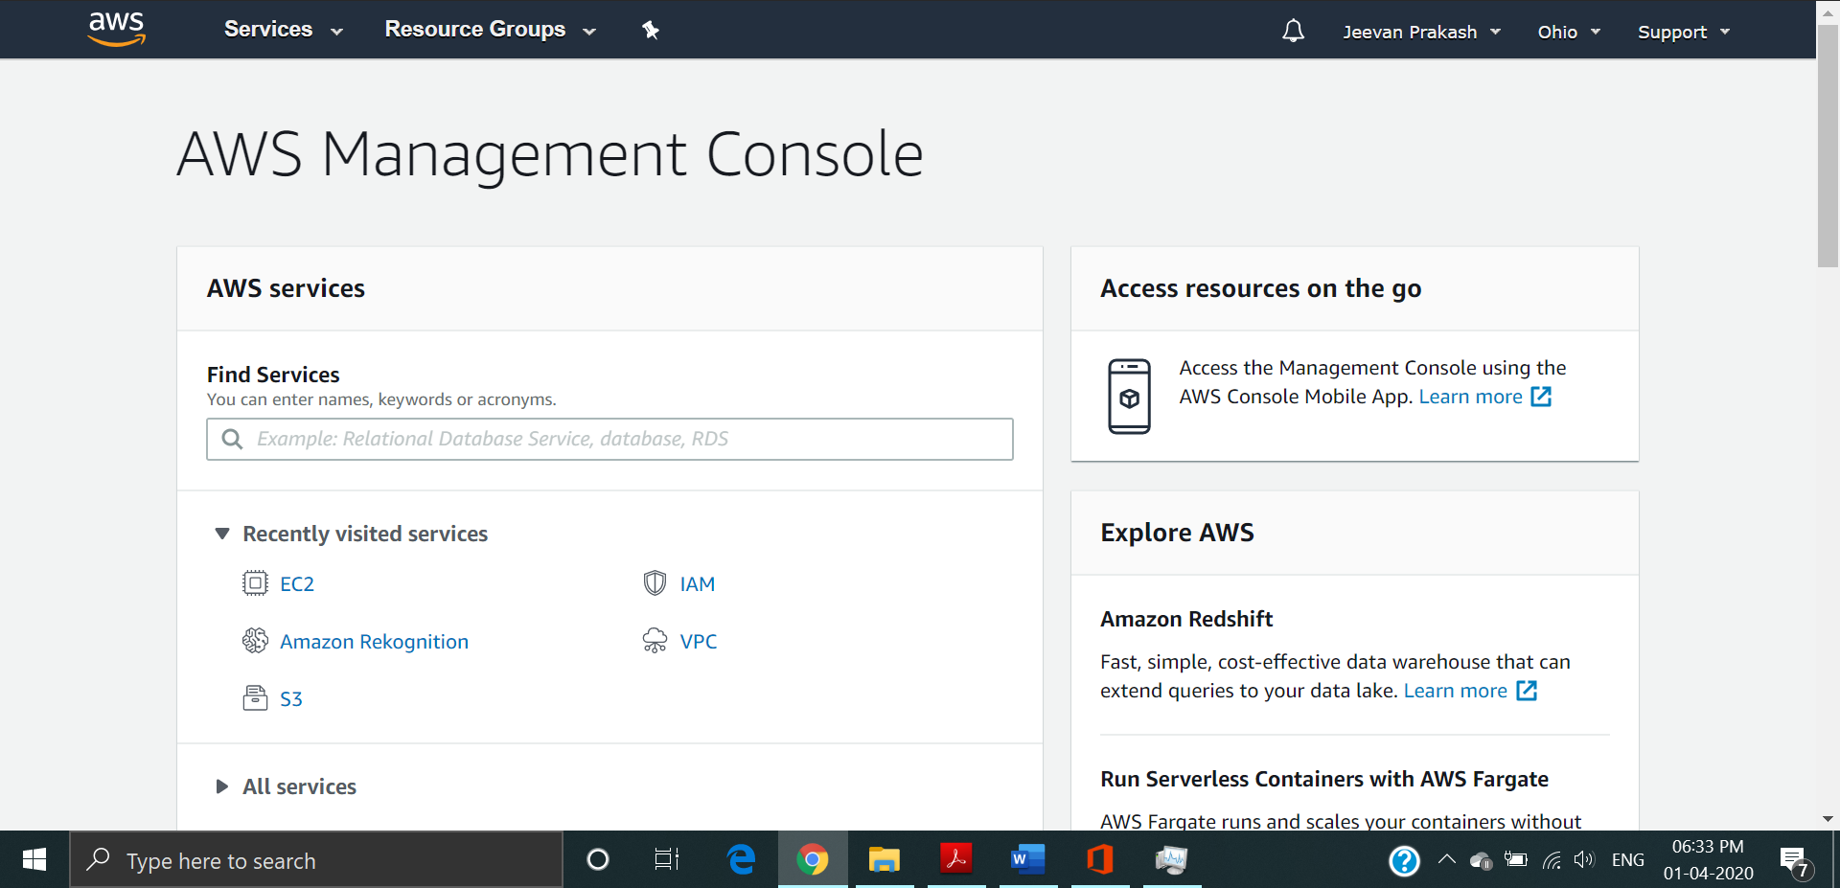

1. EC2 Dashboard

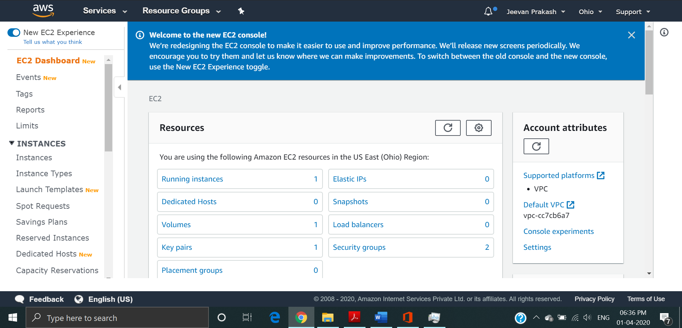

1. S3 Dashboard

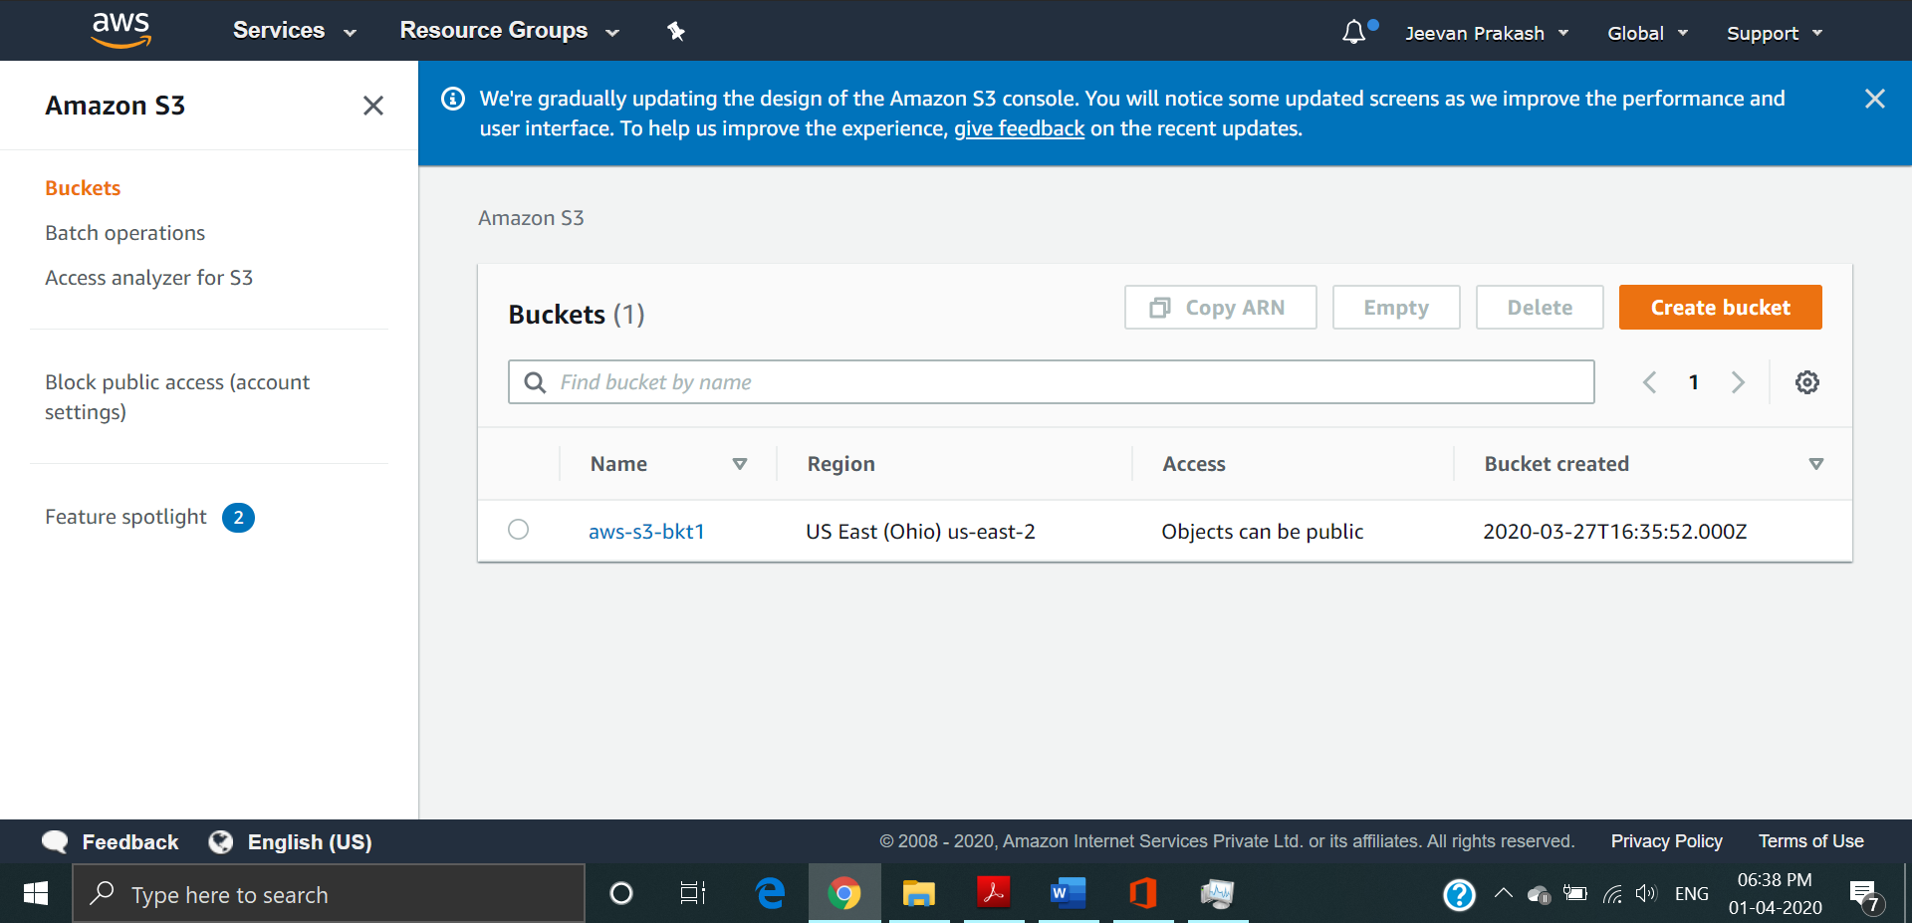

1. Rekognition Dashboard

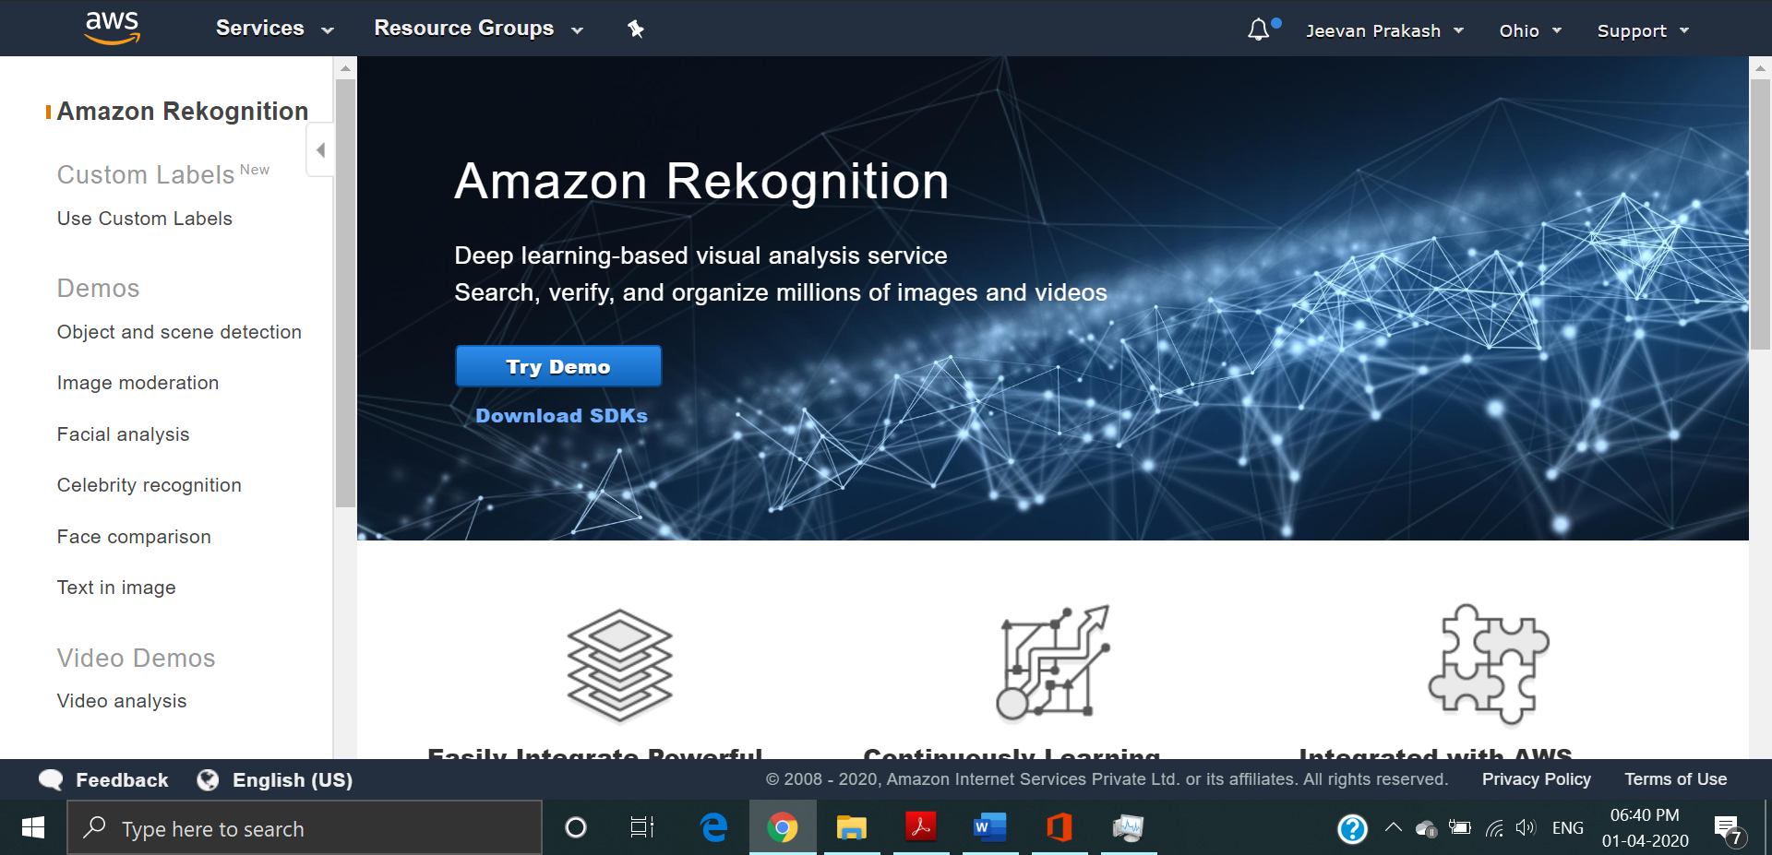

**EC2:**

1. Choosing an AMI

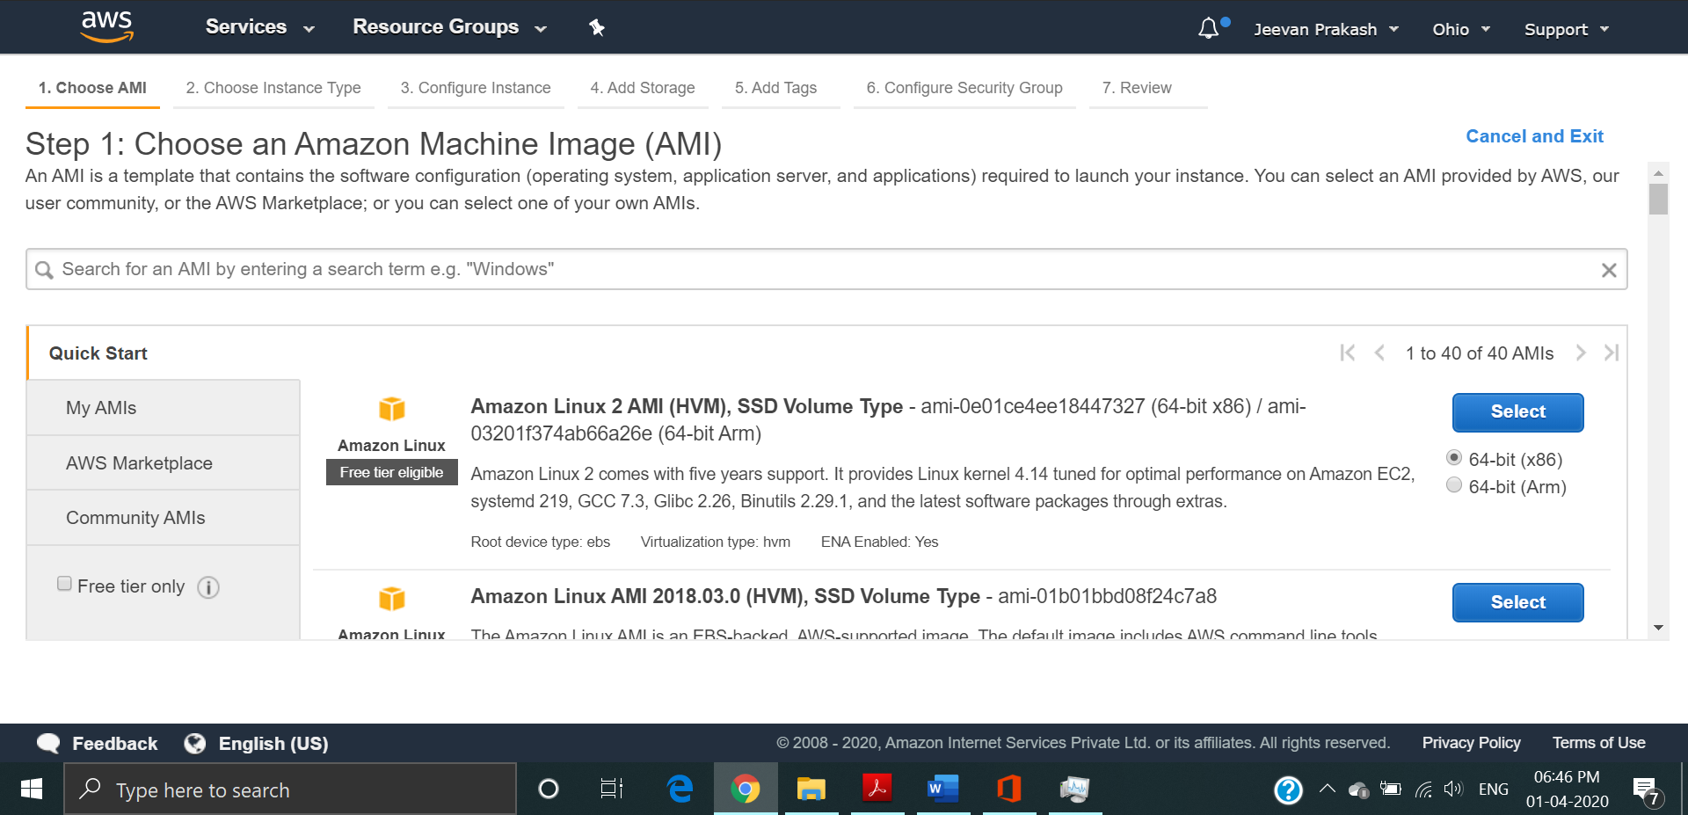

1. Choosing an Instance Type

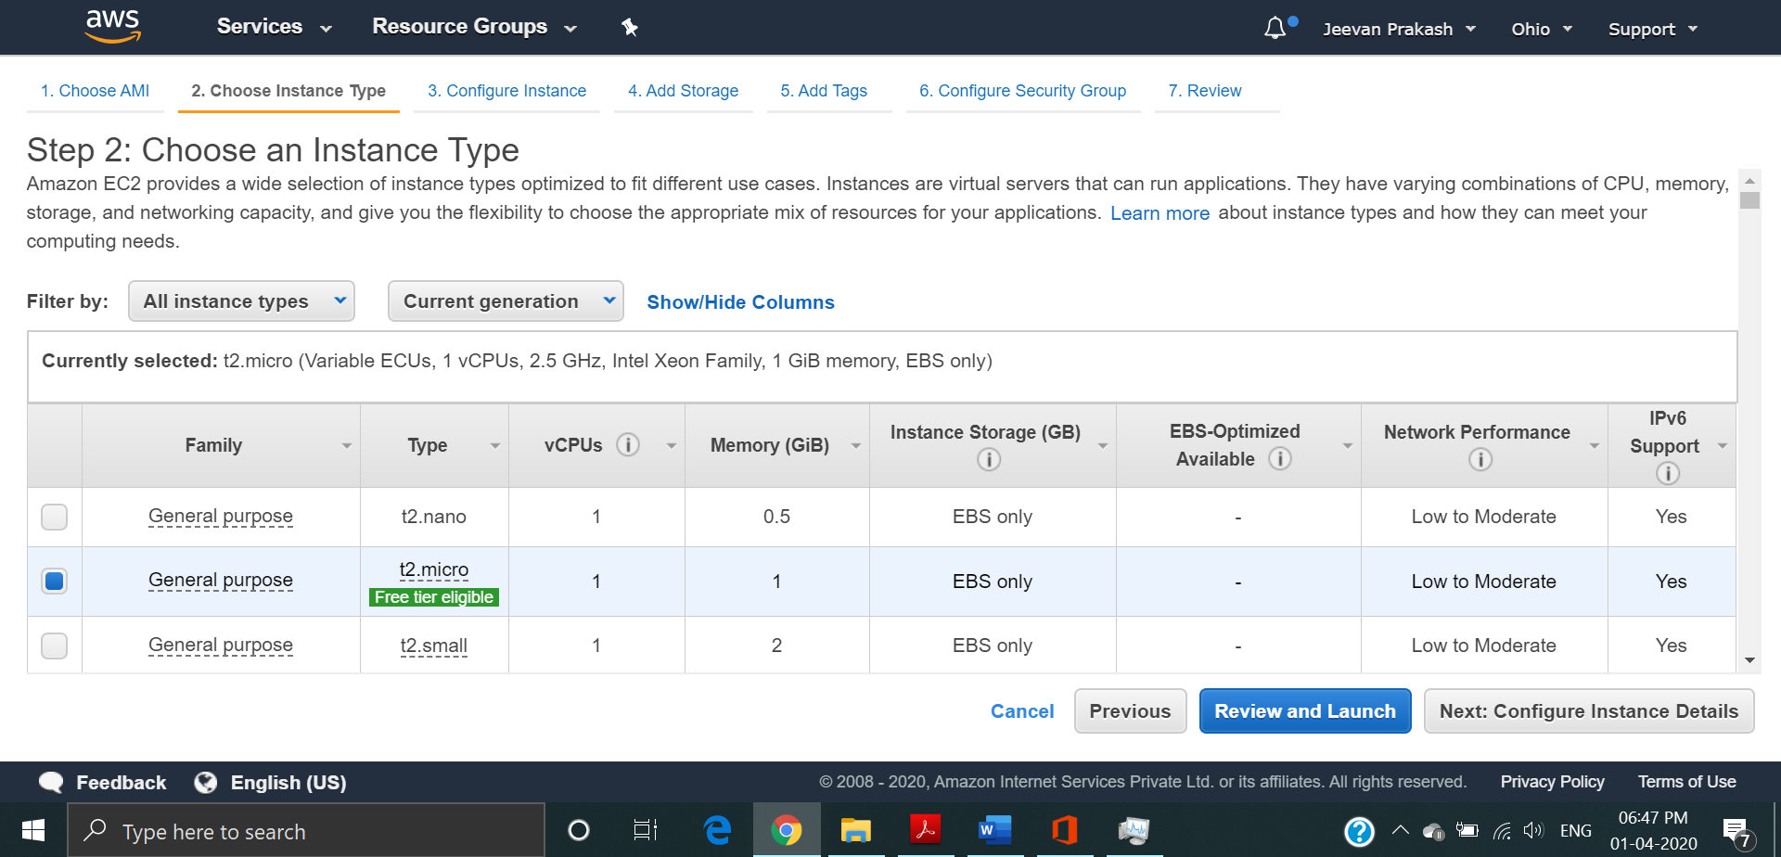

1. Adding Storage

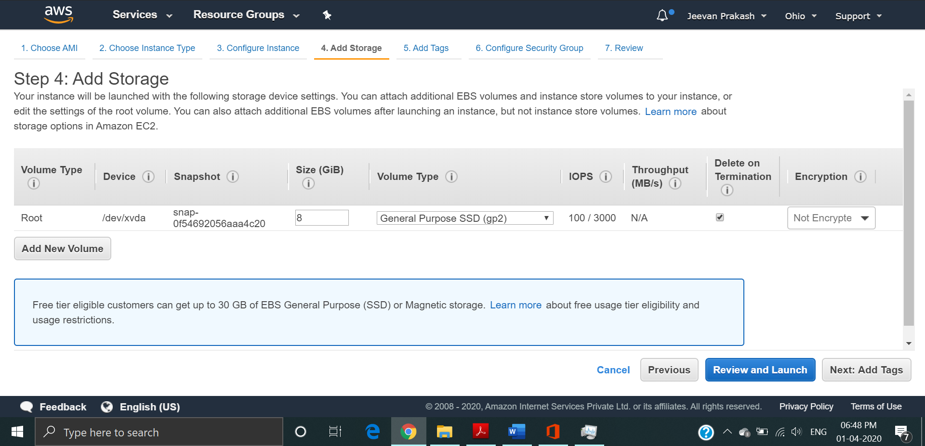

1. Configuring Security Group

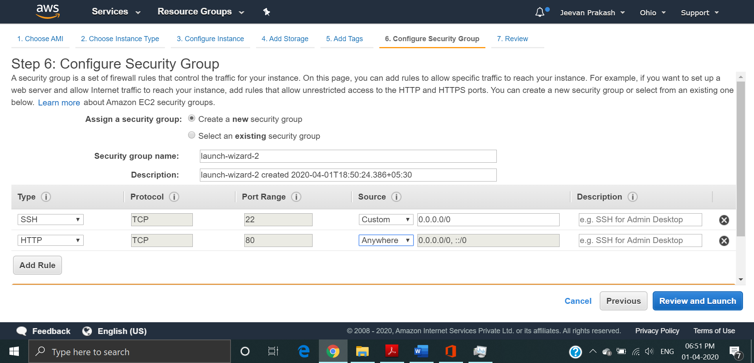

1. Key Pair Download

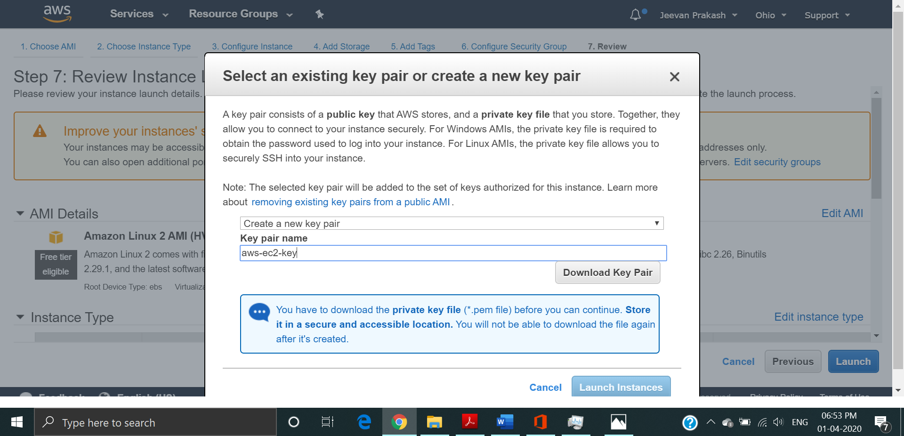

1. PuTTYgen conversion from pem to ppk

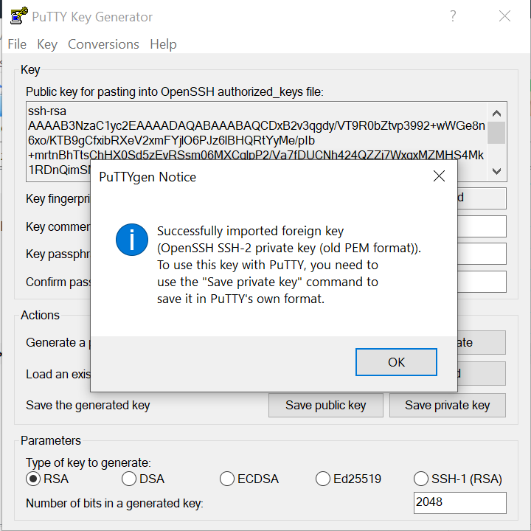

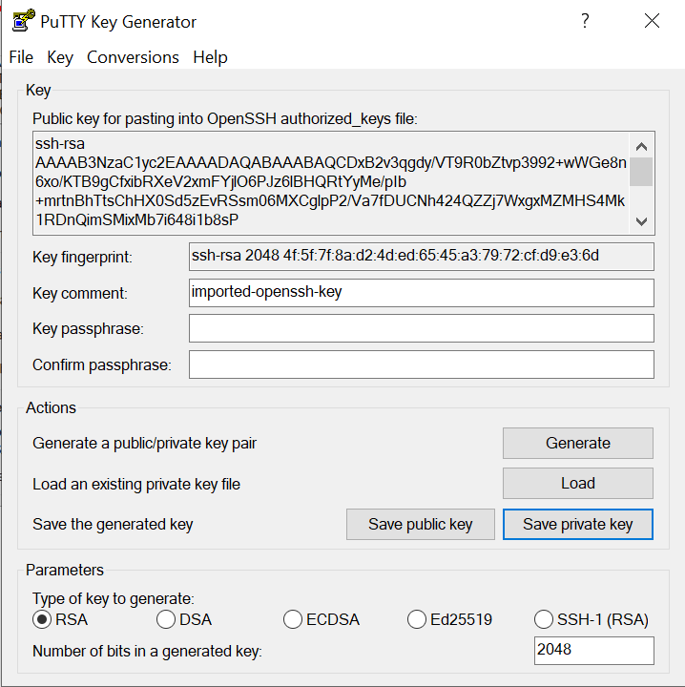

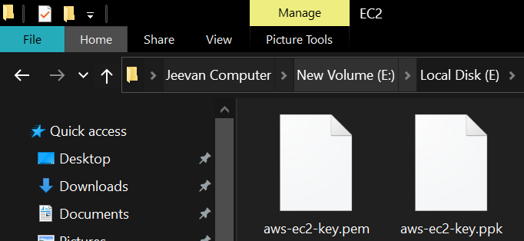

1. Logged in EC2 black screen

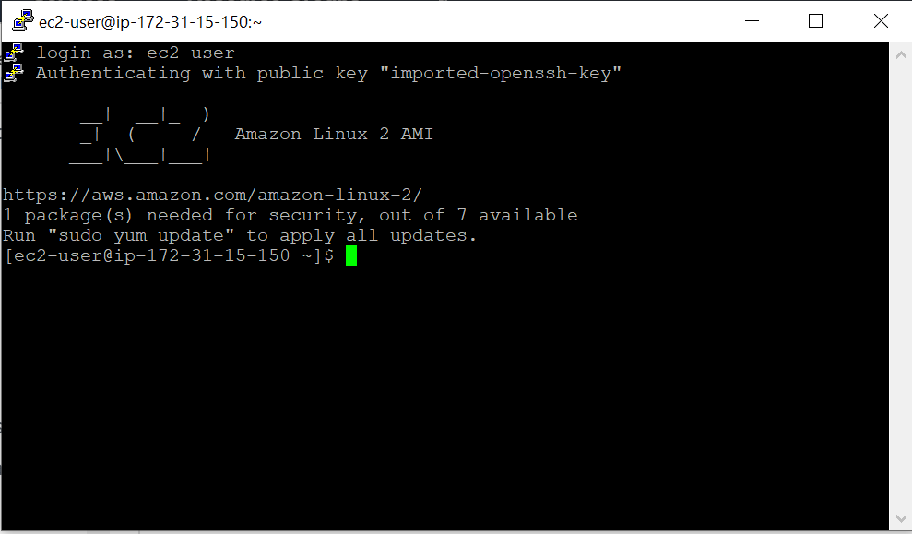

**S3:**

1. Creating a bucket

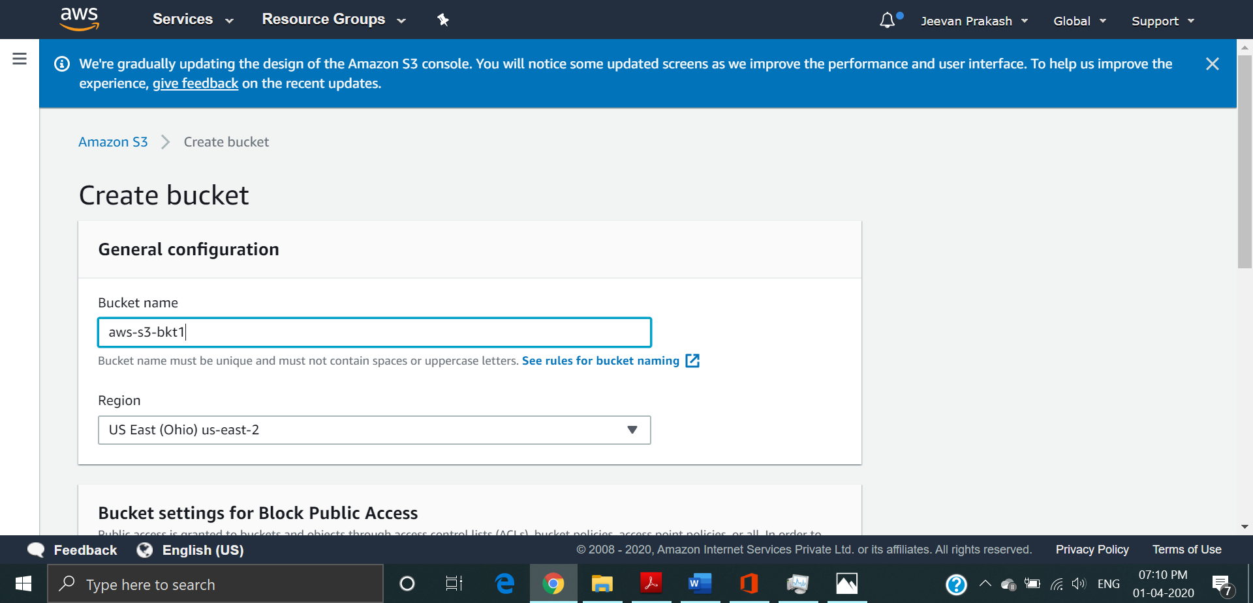

1. Uploading an Object

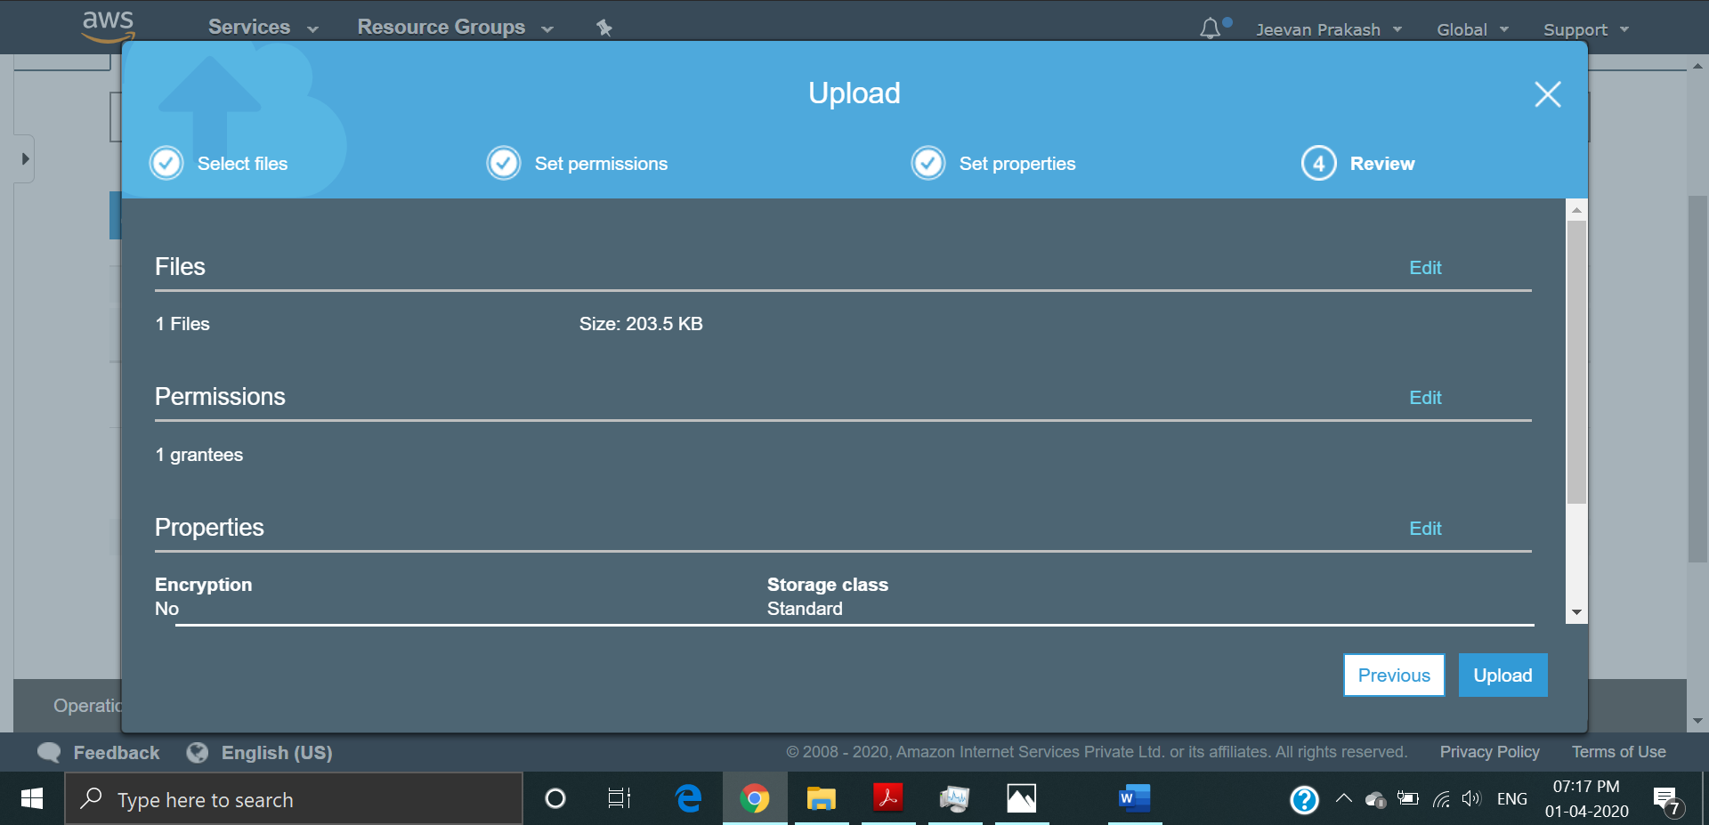

1. Enabling Static Website

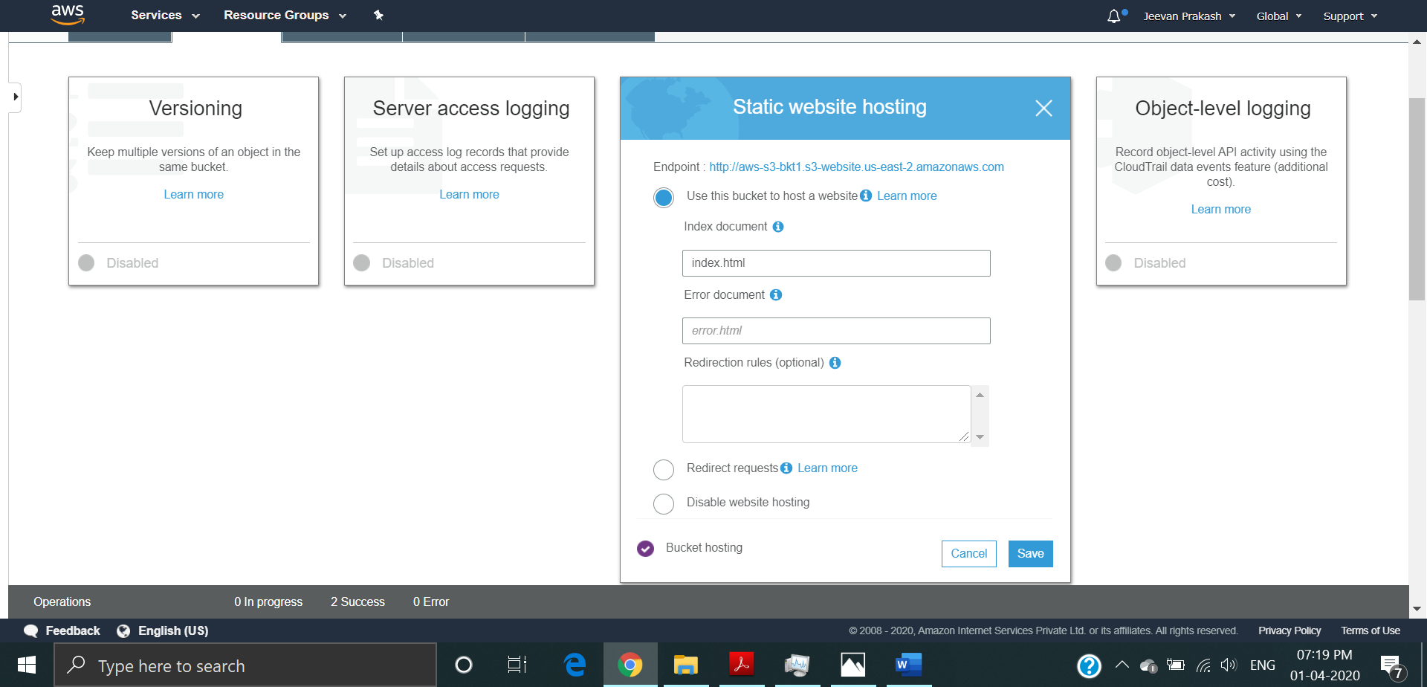

1. Making the Object Public

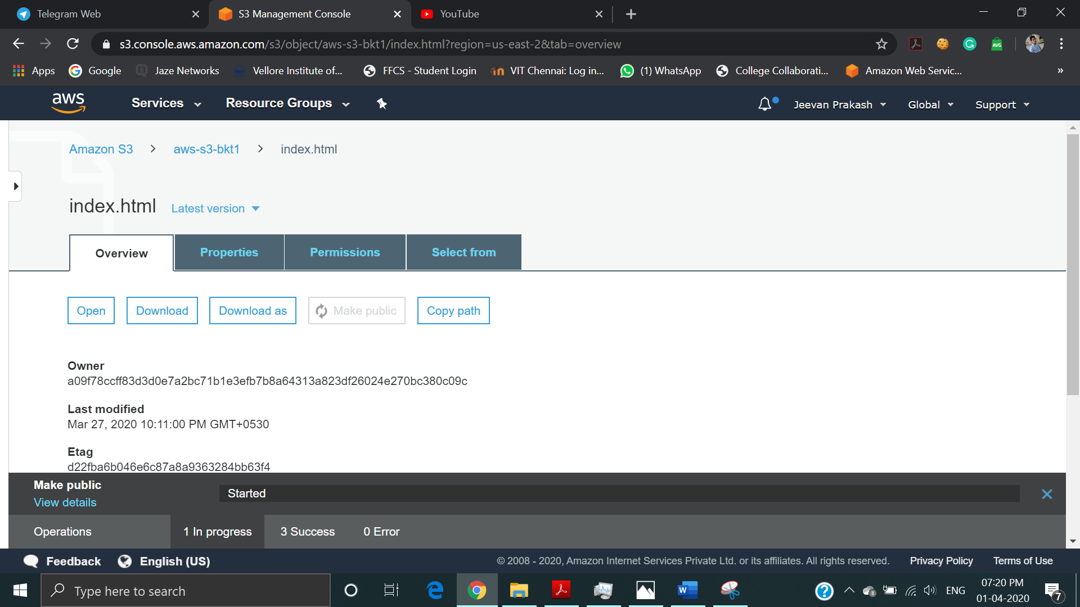

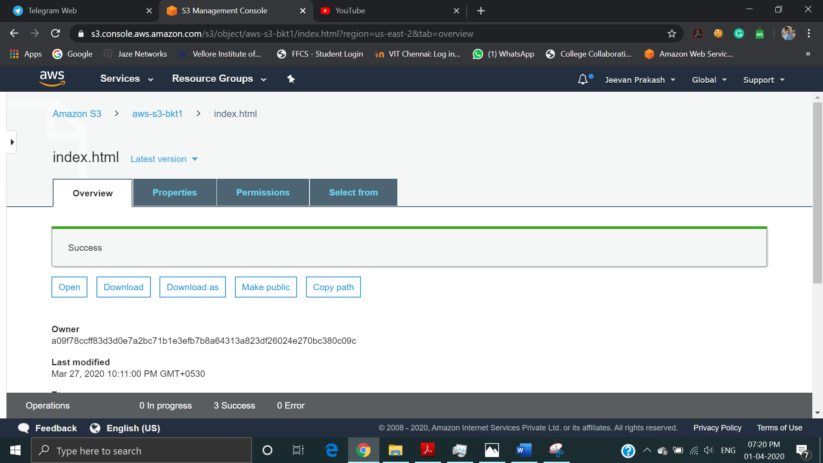

1. Checking the S3 link on the browser

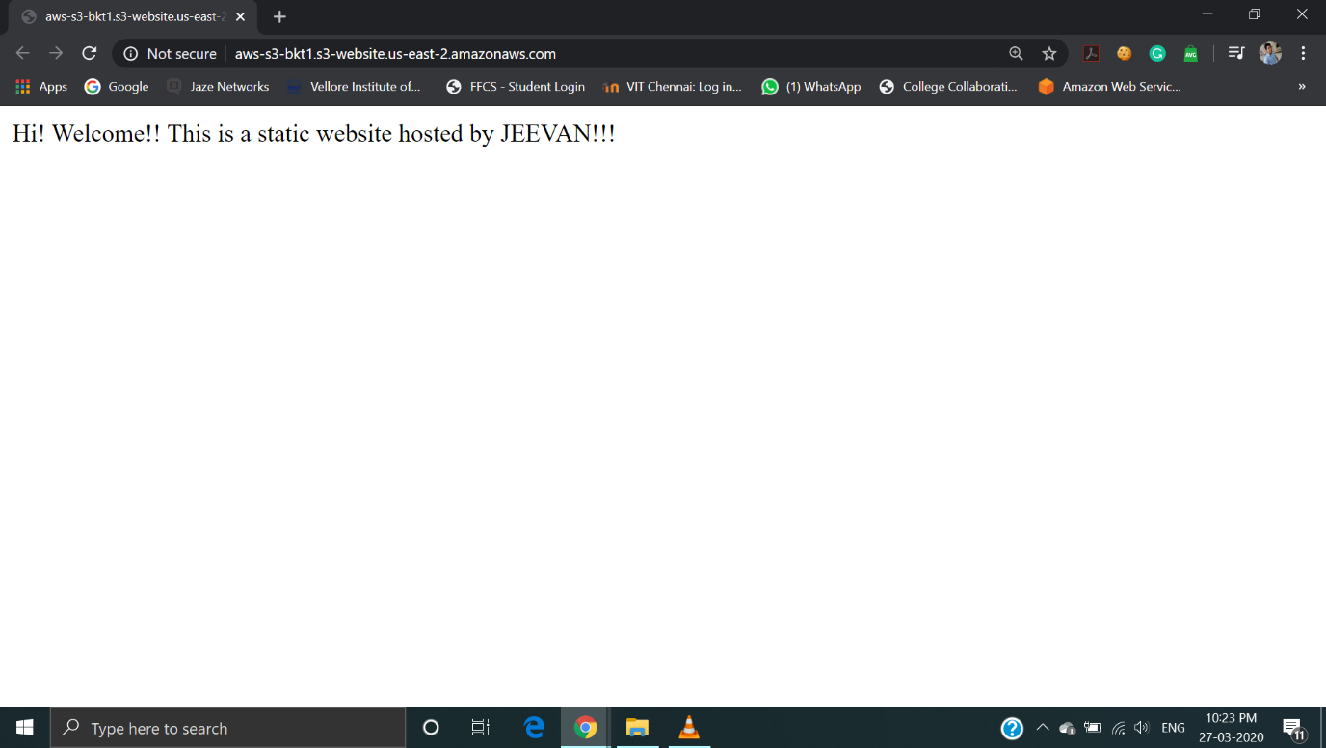

**Rekognition:**

1. Face Detect

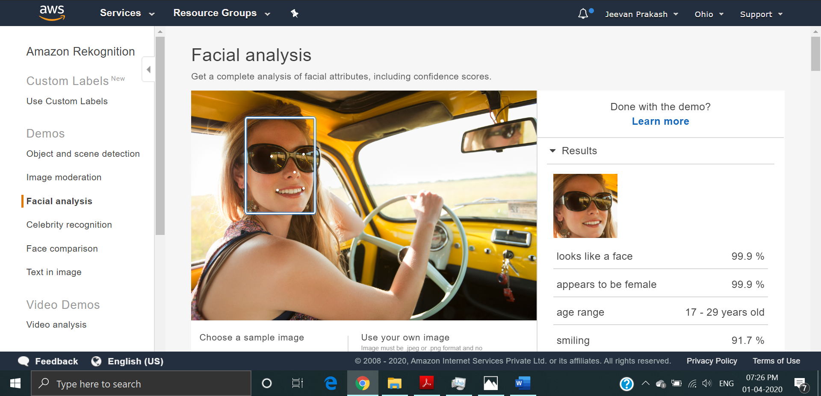

1. Face Compare

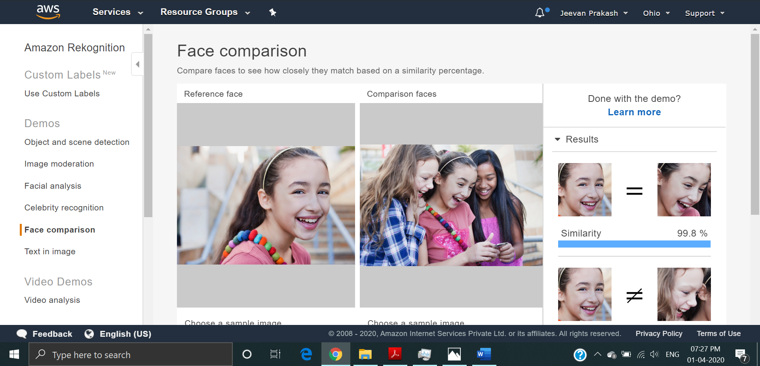

1. Celebrity Recognition

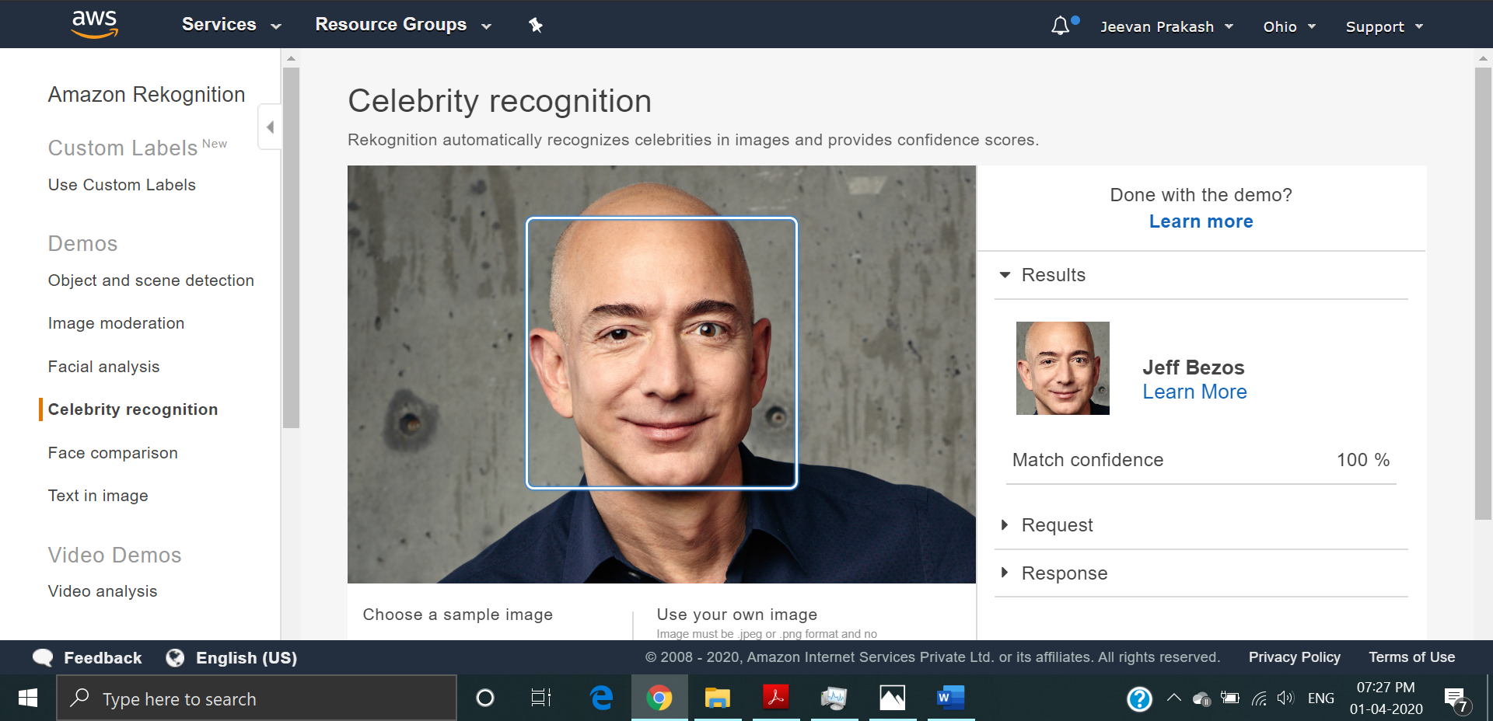

1. Text in Image

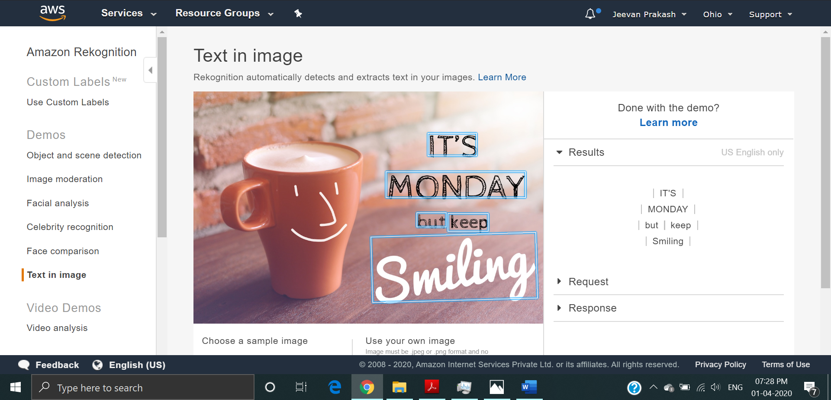

**EC2 and S3:**

1. Installing aws-sdk

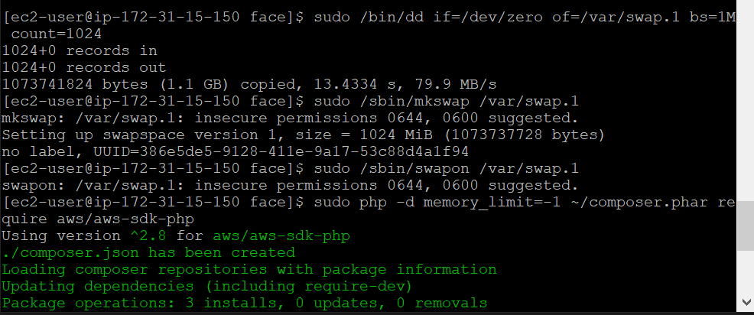

1. Installing php

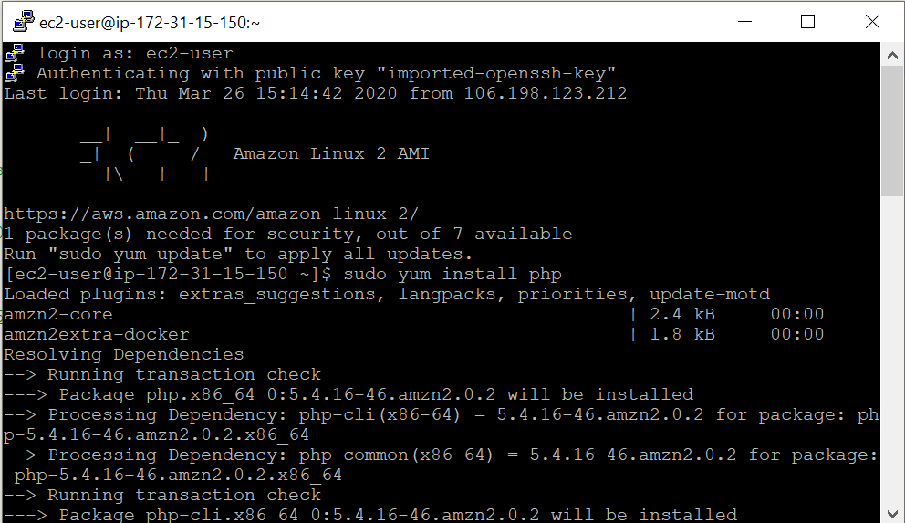

1. index.php file code

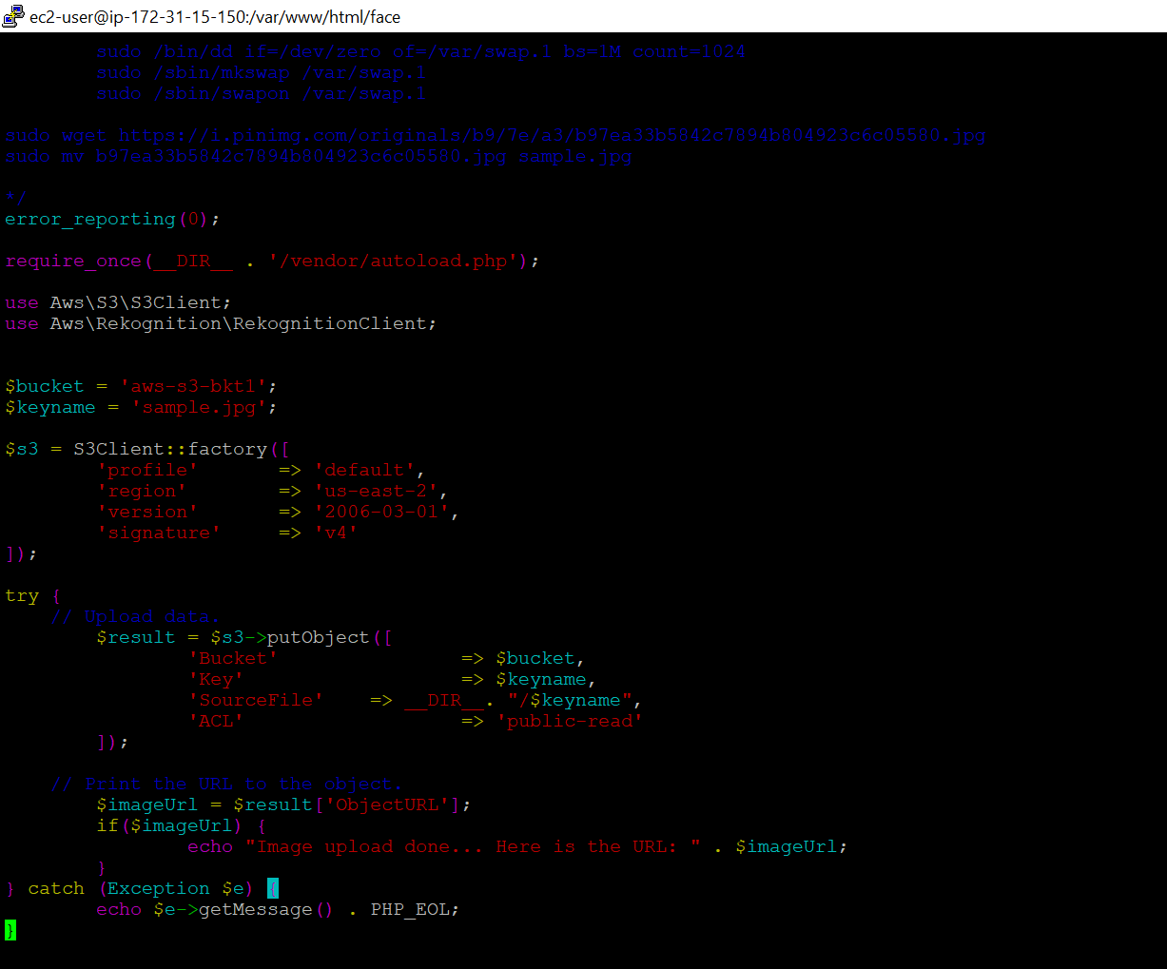

1. Upload success screenshot



**EC2 and Rekognition:**

1. Face Detect success screenshot

